PIZZA SALES SQL QUERIES
A. KPI’s
1. Total Revenue:
SELECT SUM(total_price) AS Total_Revenue FROM pizza_sales;
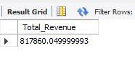
2. Average Order Value
SELECT (SUM(total_price) / COUNT(DISTINCT order_id)) AS Avg_order_Value FROM pizza_sales
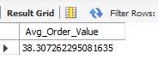
3. Total Pizzas Sold
SELECT SUM(quantity) AS Total_pizza_sold FROM pizza_sales
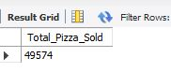
4. Total Orders
SELECT COUNT(DISTINCT order_id) AS Total_Orders FROM pizza_sales
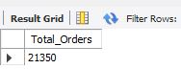
5. Average Pizzas Per Order
SELECT ROUND (SUM(quantity)/COUNT(DISTINCT order_id),2 )AS Avg_pizza _Per_Order FROM pizza_sales;
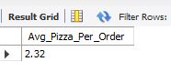

B. Daily Trend for Total Orders

SELECT
DATENAME(order_date) AS order_day,
COUNT(DISTINCT order_id) AS total_orders
FROM pizza_sales
GROUP BY DATENAME(order_date)
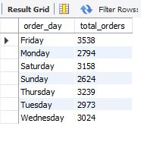

C. Monthly Trend for Orders
select MONTHNAME(order_date) as Month_Name,
COUNT(DISTINCT order_id) as Total_Orders
from pizza_sales
GROUP BY MONTHNAME (order_date)
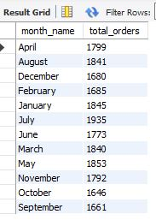

D. % of Sales by Pizza Category

SELECT pizza_category, CAST(SUM(total_price) AS DECIMAL(10,2)) as total_revenue,
CAST(SUM(total_price) * 100 / (SELECT SUM(total_price) from pizza_sales) AS DECIMAL(10,2)) AS PCT
FROM pizza_sales
GROUP BY pizza_category
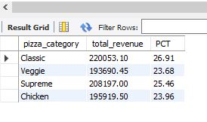
E. % of Sales by Pizza Size
SELECT pizza_size, CAST(SUM(total_price) AS DECIMAL(10,2)) as total_revenue,
CAST(SUM(total_price) * 100 / (SELECT SUM(total_price) from pizza_sales) AS DECIMAL(10,2)) AS PCT
FROM pizza_sales
GROUP BY pizza_size
ORDER BY pizza_size
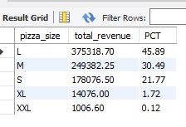

F. Total Pizzas Sold by Pizza Category
SELECT pizza_category, SUM(quantity) as Total_Quantity_Sold
FROM pizza_sales
GROUP BY pizza_category
ORDER BY Total_Quantity_Sold DESC
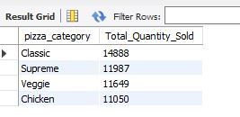

G. Top 5 Pizzas by Revenue
SELECT pizza_name, SUM(total_price) AS Total_Revenue
FROM pizza_sales
GROUP BY pizza_name
ORDER BY Total_Revenue DESC
LIMIT 5;
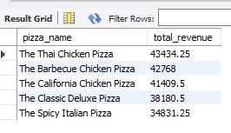
H. Bottom 5 Pizzas by Revenue
SELECT pizza_name, SUM(total_price) AS Total_Revenue
FROM pizza_sales
GROUP BY pizza_name
ORDER BY Total_Revenue ASC
LIMIT 5;
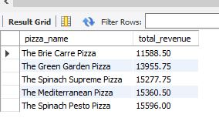
I. Top 5 Pizzas by Quantity
SELECT pizza_name, SUM(quantity) AS Total_Pizza_Sold
FROM pizza_sales
GROUP BY pizza_name
ORDER BY Total_Pizza_Sold DESC
LIMIT 5;
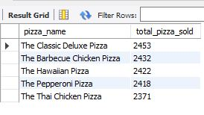
J. Bottom 5 Pizzas by Quantity
SELECT pizza_name, SUM(quantity) AS Total_Pizza_Sold
FROM pizza_sales
GROUP BY pizza_name
ORDER BY Total_Pizza_Sold ASC
LIMIT 5;
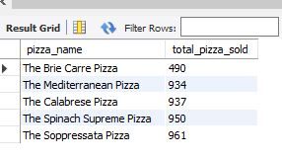
K. Top 5 Pizzas by Total Orders
SELECT pizza_name, COUNT(DISTINCT order_id) AS Total_Orders
FROM pizza_sales
GROUP BY pizza_name
ORDER BY Total_Orders DESC
LIMIT 5;
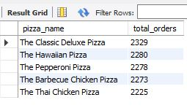
L. Bottom 5 Pizzas by Total Orders
SELECT pizza_name, COUNT(DISTINCT order_id) AS Total_Orders
FROM pizza_sales
GROUP BY pizza_name
ORDER BY Total_Orders ASC
LIMIT 5;
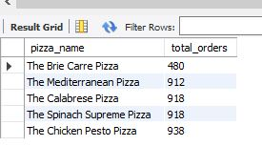
NOTE
If you want to apply the pizza_category or pizza_size filters to the above queries you can use WHERE clause. Follow some of below examples
SELECT Top 5 pizza_name, COUNT(DISTINCT order_id) AS Total_Orders
FROM pizza_sales
WHERE pizza_category = 'Classic'
GROUP BY pizza_name
ORDER BY Total_Orders ASC

WHERE MONTH(order_date) = 2 means:
Select only the orders that happened in February. 📅
SELECT pizza_category, SUM(quantity) as Total_Quantity_Sold
FROM pizza_sales
WHERE MONTH(order_date) = 2
GROUP BY pizza_category
ORDER BY Total_Quantity_Sold DESC

